**Lab Experiment 10**

**Problem statement:** Write a JQuery code to give animation to div on click of button.

**HTML Code:**

<!DOCTYPE html>

<html>

<head>

<script src="https://ajax.googleapis.com/ajax/libs/jquery/3.6.4/jquery.min.js"></script>

<script>

$(document).ready(function(){

$("button").click(function(){

var div = $("div");

div.animate({right: '130px'}, "fast");

div.animate({fontSize: '3.8em'}, "slow");

});

});

</script>

</head>

<body>

<button>Start Animation</button>

<div style="background:#98bf21;height:100px;width:200px;position:absolute;">HELLO</div>

</body>

</html>

**Output:**

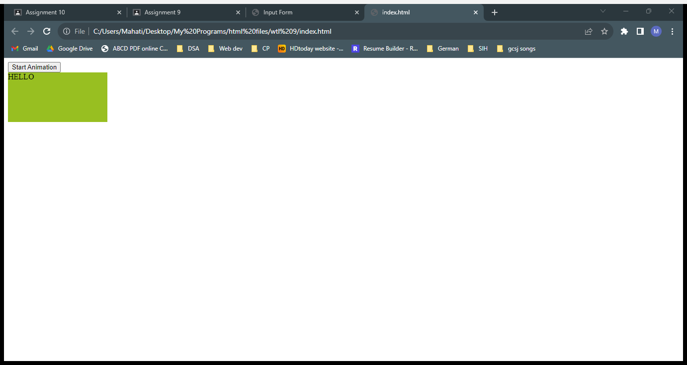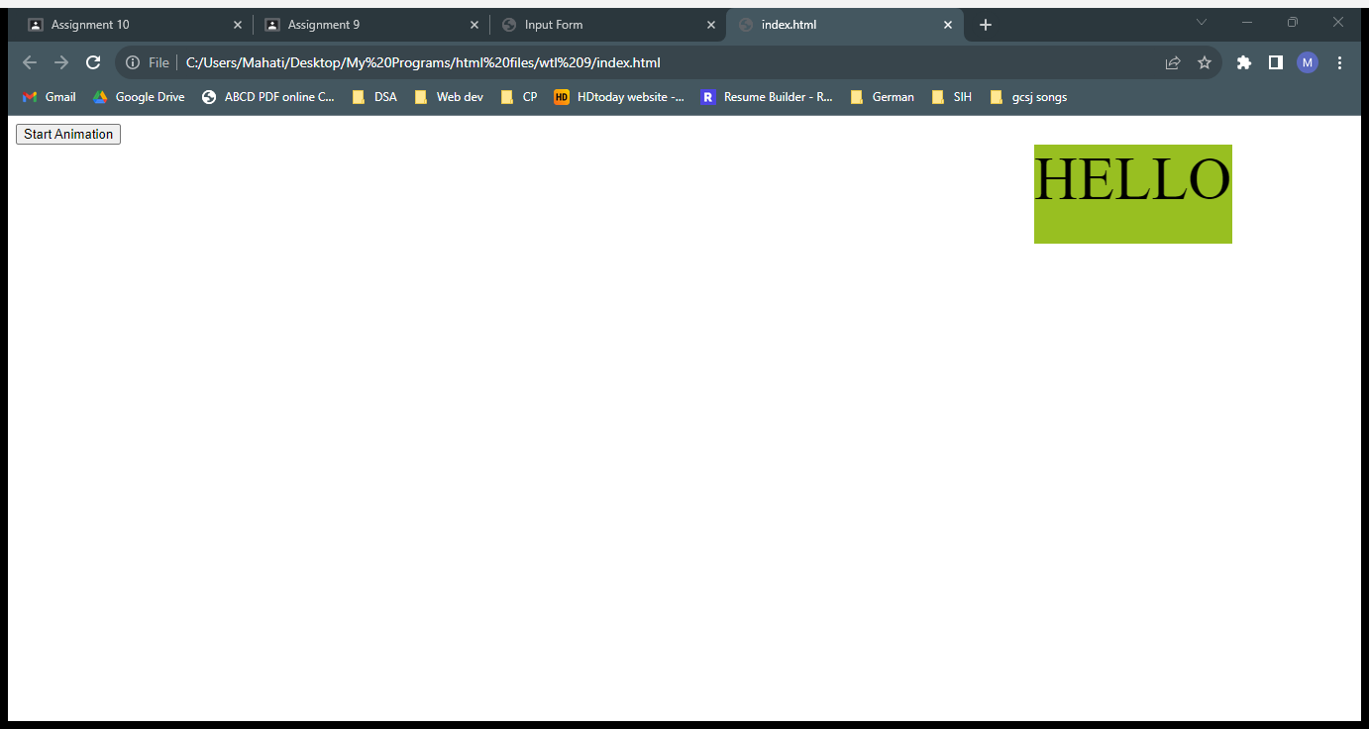

**Explanation:**

jQuery is a JavaScript library designed to simplify HTML DOM tree traversal and manipulation, as well as event handling, CSS animation, and Ajax. Here, jQuery is used to animate the div by moving the div to the right, and changing the font size.